

Merkato Version 2.0.1 Desktop Help
Desktop Interface 3
Spot Market vs. Reservation Market Agents 3
Configuration Wizard 4
Merkato Desktop Agents 5
Agent Download 5
Arranging Panels 7
Upload Function 8
Connect/Start/Stop 8
Spot Market Agent Window 10
Resource Panel 10
Units Panel 10
Valuations – General 11
Budget Valuation 14
Budget-with-limits Demand 19
Inelastic Demand Valuation 30
Elastic Demand Valuation 39
Logarithmic Valuation 43
Strategy – General 50
Automatic Strategy 56
Manual Strategy 60
News 65
Allocation 73
Auction Chart 78
Auction Table 92
Uploading and Exiting 104
Help 116
Reservation Market Agent Window 119
Resource Panel 125
Reservation Strategy 129
Reservations Table 148

Desktop Interface
The “Desktop” interface allows you to purchase bandwidth through a series of user-selectable panels. Your “agent” is brought to your desktop and bids on your behalf from there.
You access the Desktop through the same login interface as the Wizard, but select “Desktop” as the Interface Choice.
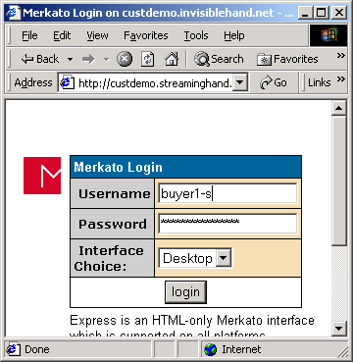
When the Desktop Interface is accessed, the following window will appear.
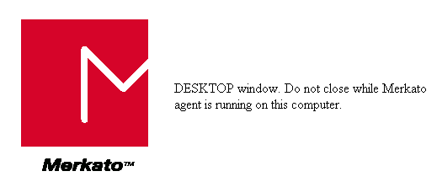
Note the instructions to not close the window. You may browse to other sites, but must leave this browser window open for the Merkato desktop to continue operating properly.
The first Desktop window you will see is the Merkato Desktop. This is the window from which you will download one or more Merkato agents.
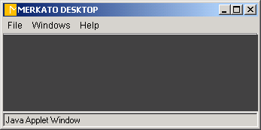

Spot Market vs. Reservation Market Agents
There are two ways to purchase bandwidth in a Merkato system. You may request and receive a fixed amount of bandwidth, at a fixed price, for a fixed term, or you may create a bidding strategy and contend for bandwidth with other buyers at frequent intervals. The first method is called the Reservation market and uses a reservation agent. The second method is called the Spot market and uses a spot agent. Depending on how your administrator has set up your Merkato system, you may have separate usernames for each type of agent or they may share a common username and password.
We recommend that if you wish to purchase bandwidth on the spot market, you use the Configuration Wizard to set up your initial configuration. Later, you may make changes through the Spot Agent interface, or return to the Configuration Wizard.

Configuration Wizard
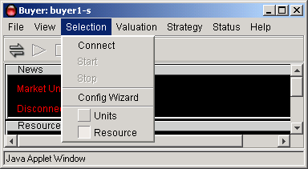
The “Wizard” interface walks you through the steps to set up Merkato to obtain bandwidth on your behalf. The Wizard may be used alone (when launched from the original login screen), to alter settings to your agent in the “garage”. It may also be used to alter settings in your agent on your desktop when launched from a pull-down menu-bar in the Desktop interface.
When “Wizard” is first launched, the following panel appears:
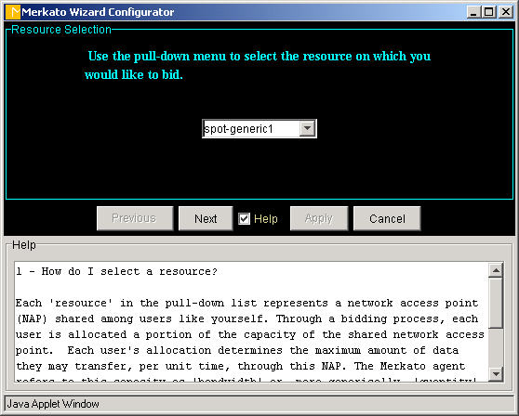
You will be guided step-by-step in the process of making the following configuration decisions:
- The resource from which you wish to purchase bandwidth
- The currency, quantity, and time units with which you would like to express your purchasing requirements. (Changes can be made at any time and your previously entered values will be scaled to match your new units)
- Your minimum bandwidth requirements
- Your maximum bandwidth requirements
- Your budget for purchasing bandwidth
- What state you wish your agent to be left in following the configuration changes (bidding or non-bidding)
Each panel is accompanied by a “help” subpanel which can be activated using the check box at the bottom of the screen. The “help” panel provides information about the impact of the parameter you are setting and provides advice on making a choice.
The values configured in your agent at the time the Wizard is activated are displayed as initial values in the applicable fields.
You may use “Cancel” at any time to exit the Wizard without making changes. You will be asked to confirm your desire to exit the Wizard with a dialog box such as the one below.
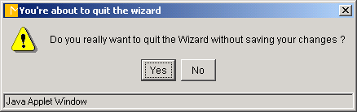
Use the “Next” and “Previous” buttons to navigate forward and backward through the Wizard. Until you press “Apply” at the last screen, none of your changes take effect. When you press “Apply”, you will see the following confirmation screen, at which time you can confirm your desire to apply your changes, or return to the Wizard.


Merkato Desktop Agents
You may use one or more Merkato Desktop Agents to obtain bandwidth and provide status information.

Agent Download
To download an agent, select the “Download Agent” command from the “File” menu-bar.
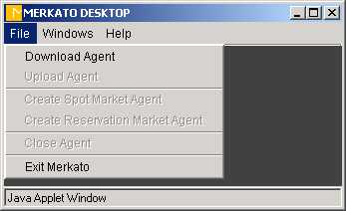
You will be prompted to enter the username and password for the desired agent. By default, this will be the same as the username and password you used to access the Desktop interface from the initial login (the fields will be populated with this information), but you may specify another valid username and password to download another agent.
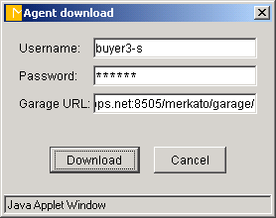
When downloaded, you will see an agent window similar to the one, below.
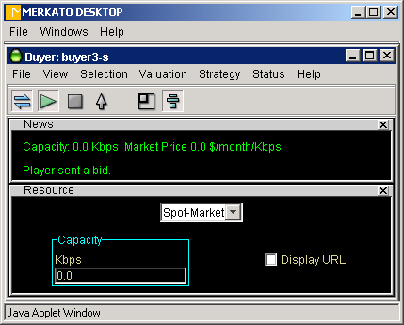
By default, all agent windows are constrained to be viewed from within the Desktop window. If you wish the agent window to appear as an independent window on your Windows screen, use the “Detach” function from the Desktop menu-bar, under “Window”, as shown below.

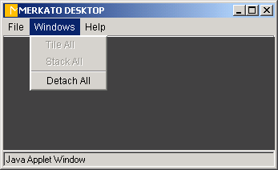
When the “Detach All” function is activated, a check will appear beside the name in the menu-bar list to indicate this.

Arranging Panels
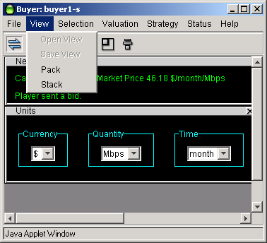

The agent window consists of multiple panels which can be displayed or not displayed as the user wishes.
By default, panels are stacked, as shown below. Each time a panel is selected for viewing, it appears beneath the one previously activated. If the user wishes to close a panel, they may either use the close-box tab at the upper right hand corner of the window (looks like an “x”), or re-select the panel in the pull-down menu bar lists. The window will close and the other windows will fill in the spot it had occupied.

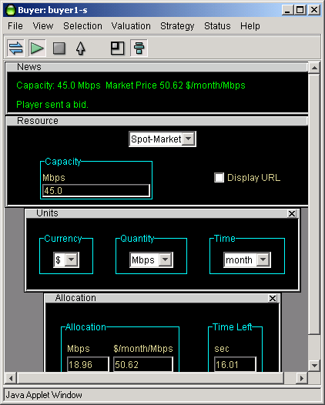
If you wish more free-form placement of windows, then click on the “Stack” icon (at the far right of the icon bar) or select “Stack” from the pull-down menu under “View”. Merkato panels can be arranged at will and even overlapped. If a panel is closed, the other panels do not move to occupy the vacant space.
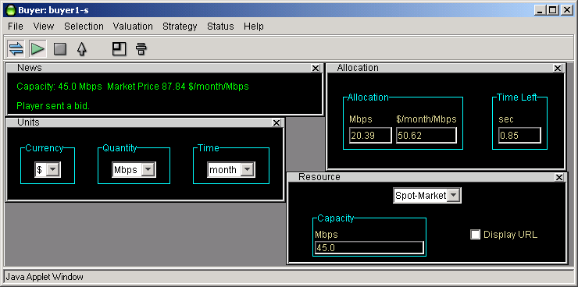
To resize the agent window to exactly match the panels displayed, press the “Pack” icon (second from right) or use the equivalent function under the “View” menu-bar.

Upload Function
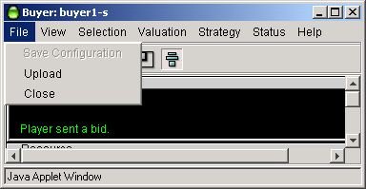
Your agent will obtain bandwidth for you by sending bids to a Resource Agent. Your agent may continue to bid on your behalf from a “garage” co-located with the Resource Agent when you close the agent on your desktop. This is known as “uploading”. When you upload your agent, all configuration changes are saved and the agent on your desktop is closed. Uploading is accomplished by either pressing the up-arrow on the icon bar (fourth from left) or selecting the equivalent function under the “File” menu-bar.

Connect/Start/Stop
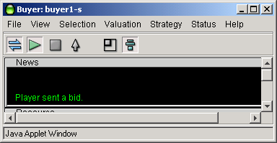
The three icons at the upper left of the icon bar indicate “Connect”, “Start” and “Stop” respectively.
When you first download an agent, it will often be disconnected from the auction. Your agent will not bid or allow you to view any status if disconnected, although you may change and save configuration settings. The “Disconnect” state is indicated by the connect symbol on the icon bar (to the far left) being un-depressed and un-colored.
When you connect to the auction, by depressing the icon, or selecting “Connect” from under the “Selection” menu-bar item, you may observe the auction, but are not participating in it. The Auction Chart and Auction Table will show you the current auction in progress and allow you to make a determination whether or not you wish to join it.
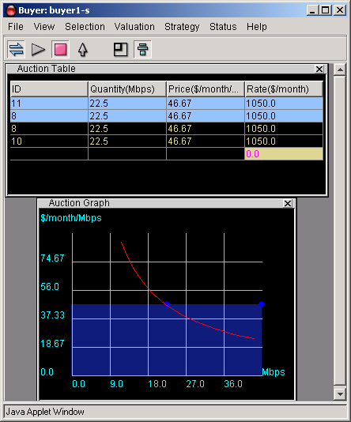
When you wish to start bidding, either press the “Start” icon (second from left on icon bar) or select the “Start” list item under the “Selection” menu-bar label. Bidding will start immediately with the current active settings.
To cease bidding, press the “Stop” icon (third from left on icon bar) or select the “Stop” list item under the “Selection” menu-bar label. Bidding will cease and you will not only be returned to “Stop” mode, but will be disconnected as well. To begin previewing the auction again, you will need to “Connect” once more.
Note that if more than one user has access to the Merkato username and password, it is possible that one bidder will be previewing an auction and be observing his own agent bidding on their behalf, either in the “garage” or on another user’s desktop. Should the user previewing the auction decide to press “Start” to begin bidding, their agent will gain control of the bidding process and the other agent in the garage, or other user’s desktop, will be disconnected. The last user to log in successfully always “wins” control of the agent, and the previous user will receive an error message, as shown below, indicating that their agent is no longer bidding.
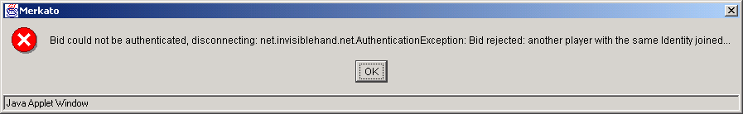

Spot Market Agent Window
The agent window consists of multiple panels which may be displayed, or not displayed, as the user wishes. The use of each panel will be discussed individually, in roughly the order one would expect a first-time user to access them.

Resource Panel
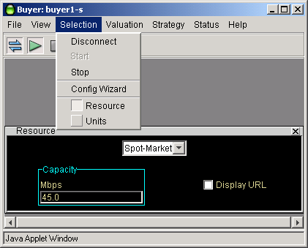
The resource panel is accessed via the “Selection” menu-bar list. If the agent is connected to the auction, the “capacity” display will indicate the total amount of bandwidth available for sale from this particular Resource Agent.
Note that a single agent can only bid on one resource at a time. If you select one resource, you automatically de-select the others. You may, however, preview other auctions (without connecting) by logging into two desktops and either continuing to bid on the second or upload the agent to the garage via the second desktop, while you continue to monitor (without connecting) via the first desktop.
In the unlikely event that you would want to know the URL of the Resource as opposed to the alias name, you can display the URL by clicking the check box at the lower right side of the panel.

Units Panel
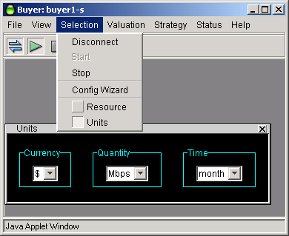
The units panel is used to select display units for all the other panels as well as for several pop-up message screens.
Currency units supported are dollars (“$”) and cents (“c”)
Quantity units supported are kilobits per second (“Kbps”), Megabits per second (“Mbps”), and gigabits per second (“Gbps”).
Time units supported are minutes (“min”), hours (“h”), days (“day”) and months (“month”)
Changes to any units selection takes effect immediately. All values are automatically scaled to reflect the new units without changing the actual value entered.

Valuations – General
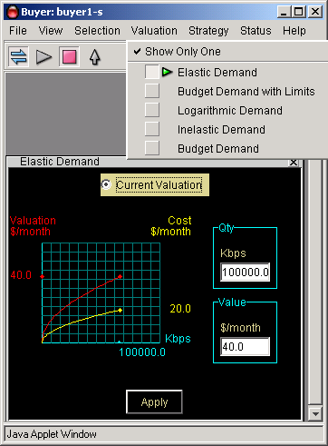
Valuations are all grouped under the “Valuation” heading in the menu-bar.
The first item in the list, “Show only one” controls whether successive selections of valuation replace the previous valuation shown, or result in multiple panels being displayed. If a check mark appears before this control, only one valuation will be shown at a time.
Each valuation has a “Current” radio button label at the top of the panel. To make a valuation active, click your mouse on this button in the desired valuation panel. The previously active valuation will automatically have its “Current” button de-selected. The green arrow in the menu-bar pull-down list also indicates which valuation is currently active.
The valuation panels represent how you, as a buyer, value varying amounts of bandwidth. Valuation panels use different parameters to change their shape and values, but all result in a representation of valuation and cost for a range of quantity (bandwidth). The chart to the left of the numerical entry boxes shows two curves, the red one is a representation of valuation vs. quantity and the yellow one is a representation of maximum cost vs. quantity. If there appears to be only one curve, it indicates that both curves are identical and overlapping.
Valuation is an abstract concept which economists use to indicate the changing value buyers put on a resource. Mathematically, it is the area under (the integral) of the curve of unit price vs. quantity curve used to determine the actual bids placed.
More valuable for non-economists is the curve of maximum cost vs. quantity. This represents the maximum out-of-pocket expense the buyer would pay were he to be allocated this amount of bandwidth and his bid determined the market price. (See the explanation of the second price auction mechanism for clarification.)
The following sections describe each valuation option in detail. The choices are:
Budget Demand – Valuation is configured to have a constant cost for all units of bandwidth.
Budget Demand with limits – Same as “budget” but you can set the minimum and maximum bandwidth for which you will offer your fixed out-of-pocket amount.
Inelastic Demand – Bidding at a constant unit price regardless of the quantity. Equivalent to a single take-it-or-leave-it bid.
Elastic Demand – Similar to Budget Demand, except you offer less out-of-pocket amounts for lower amounts of bandwidth than you do for higher amounts.
Logarithmic Demand – Use this valuation if you wish to bid aggressively at a mid-point in the quantity range and less aggressively for higher or lower amounts.
As a reference, the following chart comparing the valuations might be useful.
This chart shows the relative bidding strategies for each of the valuations, all normalized to a maximum cost of $10,000 per month and a maximum desired quantity of 100 Mbps.
Note that in selecting valuation settings you may specify a maximum quantity desired which is greater than that the seller is offering. Your agent will still begin bidding at the amount the seller is offering at the unit price as indicated from your Valuation curve. You may want to configure your valuation for amounts greater than the seller is currently offering in case they offer more bandwidth at a later date or you may simply prefer the resulting bid curve.
For all valuations, you must press the “Apply” button on the panel, or <Enter> on the keyboard for changes to parameters to take effect. (the “Apply” button changes color from yellow to blue when a parameter is changed, and back to yellow when the change takes effect). Note that changes to valuations only affect bidding if that particular valuation is active, as indicated by the radio button at the top of every panel and the green arrow in the pull-down menu list.
The relative merits and typical uses of each valuation will be discussed further in their individual sections.

Budget Valuation
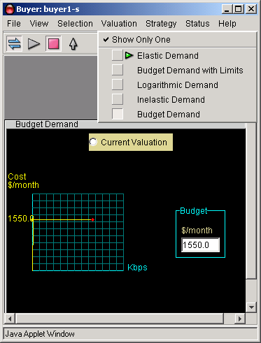
The Budget Demand valuation has a single configurable parameter – the “budget”, which is the total out-of-pocket amount you are willing to pay for any amount of bandwidth.
This is by far, the easiest valuation to understand and configure. Use it when you want to purchase the maximum amount of bandwidth possible in each auction round.
Your agent will begin by offering the unit price corresponding to your budget for all the bandwidth available. If your agent is informed it would not receive this full allocation, it will bid again, but raise the unit price offered and lower the desired quantity requested so that the out-of-pocket amount remains the same. This raises your agent in the bidder rankings and makes it more likely that it will receive the new bandwidth request. This process continues until the agent receives the requested amount of bandwidth.
There are two disadvantages to the budget valuation:
- Because your agent aggressively tries to maximize the amount of bandwidth obtained, you nearly always will pay exactly your budget for the bandwidth received.
- You could end up paying your entire budget for a very small amount of bandwidth, if other bidders are offering significantly more than you are.
An advantage of the Budget valuation is that your agent will always begin by bidding for all bandwidth the seller is offering, whether it increases or decreases over time. With most of the other valuations, you would have to adjust the maximum quantity desired parameter to match changes in seller quantity offered.
Note that the red valuation curve is not shown in the chart in the panel for the Budget valuation, only the yellow cost curve.

Budget-with-limits Demand
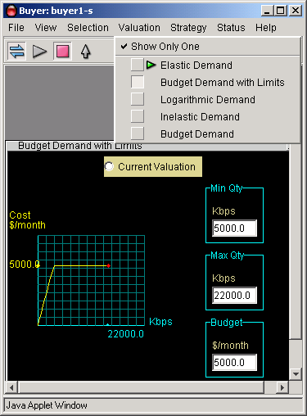
The Budget-with-limits Valuation is the one most commonly used, and the only one currently supported by the Configuration Wizard. There are three settable parameters which determine the bidding behavior for this valuation:
- Budget – The maximum out-of-pocket amount you are willing to spend.
- Max Qty – The maximum amount of bandwidth you desire
- Min Qty – The minimum amount of bandwidth for which you are willing to pay your budgeted amount.
Your agent will begin bidding by asking for your configured maximum quantity at the unit price represented by your budget. If your agent is informed that it will not receive this allocation, it will bid again by lowering the amount of bandwidth requested and raising the unit price proportionally so that the total out-of-pocket amount remains the same. This behavior continues, until either the agent receives the allocation requested, or the minimum specified quantity is reached. At this point, the agent makes one final bid for this quantity at the unit price represented by the budget. The agent will either receive this amount at the offered price, a lesser amount of bandwidth at the same unit price, or nothing at all, depending on how the auction proceeds.
There are several advantages to this valuation:
- By restricting the amount of bandwidth initially requested, you will not get more than you need and will not spend your entire budget if the market price is below your offered price.
- Also, by restricting the amount of bandwidth initially requested, you will not drive the market demand for bandwidth up quite as quickly and often pay a lower market price than you would have otherwise.
- By setting a lower boundary on bandwidth desired, you will not offer your full budget for a very small amount, should bidding become very aggressive. Of course, you run the risk of receiving no allocation of bandwidth at all and share the best-effort queue with other bidders receiving no allocation or electing not to bid.

Inelastic Demand Valuation
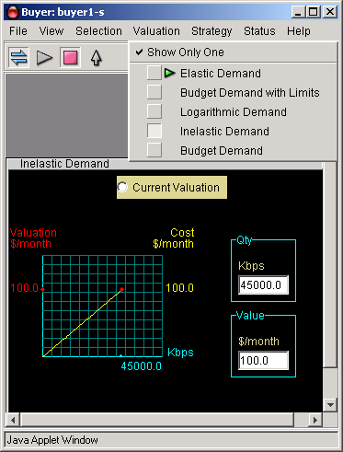
The Inelastic Demand valuation is only used in unique situations.
Mathematically, your agent offers the same unit price regardless of the quantity requested, which might at first seem desirable. Practically, however, because bids are ranked by the Resource Agent based on unit price offered, this results in an overall take-it-or-leave-it offer by your agent. You receive an allocation only if the market price stays at or below your offered price. Your agent is not allowed, as in other valuations, to offer a higher unit price for a lower quantity in order to compete further and receive an allocation.
Two configurable parameters determine the behavior of the Inelastic valuation.
- “Qty” sets the maximum quantity desired. Your agent will request this amount in it’s one and only bid.
- “Value” sets the maximum amount of out-of-pocket cost you are willing to pay for the maximum quantity desired.
The unit price that your agent will offer in bids is the “Value” divided by the “Qty”.
Note that the cost and valuation curves are identical, so only the cost (yellow) curve is shown.

Elastic Demand Valuation
The Elastic Demand Valuation is similar in concept to the budget valuation, but it bids at a reduced overall cost as the market price rises. In other words, as the market price rises, the Elastic demand agent will ask for less bandwidth than a similarly configured Budget demand agent.
The two configurable parameters for the Elastic Demand valuation are maximum quantity (“Qty”) and maximum value (“Value”). Configure the maximum quantity to correspond to the maximum quantity you would like to be allocated. Configure the maximum value to correspond to the maximum price you are willing to pay should you receive that amount of bandwidth. The maximum cost is always half of the “Value” you enter, as indicated in the chart to the left of the numerical entry boxes.

Logarithmic Valuation
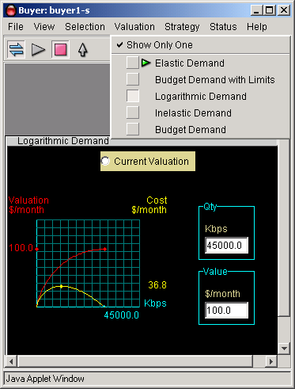
The Logarithmic valuation is unique in that the maximum cost offered for bandwidth occurs at a mid-point of quantity, rather than at the maximum specified value. Use this valuation if you wish to bid more aggressively for a certain amount of bandwidth, but progressively less aggressively for amounts above and below that amount.
There are two configurable parameters for the Logarithmic Demand valuation, maximum quantity (“Qty”) and maximum value (“Value”). You might want to set the maximum quantity based on one of two possible criteria:
- Set it to correspond to the greatest amount of bandwidth you would consider obtaining. Note that your agent’s bid is zero at this point, so it is practically impossible for you to receive this amount.
- Set the maximum quantity to place the peak cost bid at a desired quantity. The peak cost bid will be offered at around 37% of the maximum quantity you specify.
Set the maximum value to correspond to the desired maximum cost. The maximum out-of-pocket cost will be approximately 37% of the value you set, as indicated by the graph to the left of the text entry fields.

Strategy – General
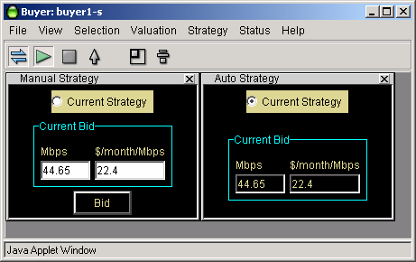
Once you have configured your valuation (the value you place on various amounts of bandwidth), you must configure how you want you agent to use that information. In this version of Merkato, there are only two strategy options for use in the Spot market: Automatic and Manual, which are explained in the subsections which follow.
As for the Valuation settings, you may view and select strategy setting independently from each otther.
To view only one strategy panel at a time, with the most recently selected panel replacing the previously selected panel, click on “Show Only One” at the top of the Strategy menu-bar list. A check mark will appear next to the list item. If you wish to view multiple strategies at one time, de-select the “Show Only One” option.
The active strategy is selected using the “Current Strategy” radio button at the top of each Strategy panel. Clicking on this button in any panel will activate that strategy and automatically de-activate any other strategies. A green arrow in the menu-bar list also indicates the current active strategy.

Automatic Strategy
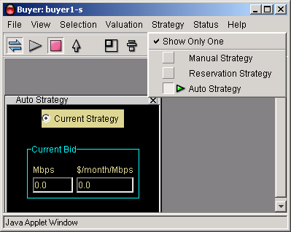
The Automatic Strategy is the one that is most commonly used. It begins by bidding for the maximum quantity (or seller quantity, which ever is less) at the unit price specified by the valuation settings. If informed that it did not obtain this amount of bandwidth, the agent will bid again, if permitted by the valuation, at an incrementally higher unit price but adjust the amount of bandwidth requested to agree with the valuation curves. This process continues until either the agent receives the amount it requested, or until it cannot to bid above the current market price based on the valuation settings.
The two display fields in the Automatic Strategy panel show the current bid; quantity in the left hand display, and unit price in the right hand display.

Manual Strategy
Manual strategy ignores the valuation settings completely and allows the user to place his own bids. Note that these bids are a one-time occurrence and are not repeated in successive auction rounds. If you wish to place a take-it-or-leave-it bid each auction round, use the Inelastic valuation and select the automatic strategy to submit the bids automatically.
To place a manual bid, enter the quantity desired in the left hand numerical entry box, and the desired unit price in the right hand numerical entry box (pay close attention to the units displayed, so you do not make an error). After both the numerical values are entered, press the “bid” button. Your bid will be submitted to the Resource Agent. You may observe the results of your bid in the Auction Table or the Auction Chart panels.
The initial displayed value in the Manual Strategy panel is the last bid placed by the Automatic Strategy. You may, if you wish, view both the automatic and manual strategy screens simultaneously and quickly activate the manual strategy if you wish to place a bid. Note that if you return to the Automatic strategy, the agent will return to bidding along the original valuation curve according to its standard bidding strategy.

News
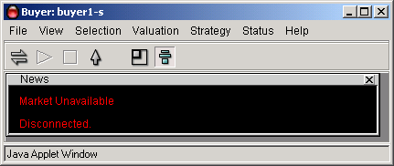
The News panel provides real-time status of your Merkato agent. When your agent is disconnected, you will see a display similar to that, above.
When connected, but not bidding, you will see a display like the one below, which indicates the capacity being offered by the seller and the current market price of the auction as it is proceeding without your agent's participation.
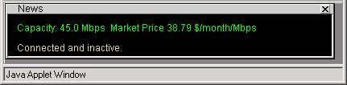
Once you begin bidding, you will see displays like the ones below, which add information indicating activity between your agent and the resource agent which conducts the auction.
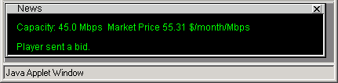
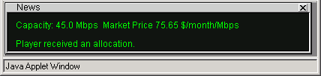

Allocation
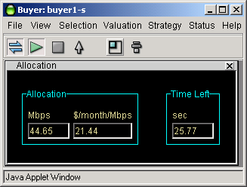
The Allocation panel provides information as to the quantity of bandwidth received and the price paid for that bandwidth at the close of each successive auction. When an allocation has been made to your agent, it appears in the left-hand side of the Allocation panel and is displayed throughout the next auction. Note that when your agent is first made active, after a period of non-bidding, he allocation indicated will be the last one made to this agent when it was last active.
The allocation panel also provides a time indicator for the current auction. Each time any bidder places a bid, the timer is reset to 60 seconds. When all bidders cease bidding (either because they are satisfied with their proposed allocation or have dropped out of the bidding at the current market price), the timer will count down to zero. At that point, an actual allocation will be made by the resource agent, during a "pause" period. The pause period is indicated by the timer label changing from "Time Left" to "Time Since", changing to a red font, and counting up rather than down, as shown below.
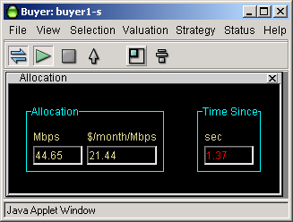

Auction Chart
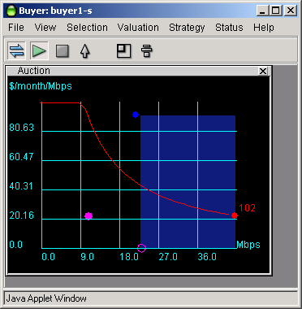
The Auction chart graphically indicates the state of the Merkato auction in progress, not only for your agent, but for all others actively bidding.
The chart elements are:
- Auto-scaling Y-axis indicating unit price (axis is scaled to show all current bids)
- Auto-scaling X-axis indicating quantity (axis is scaled to show available quantity
- Blue dots representing the last bids received from all bidders (excluding bids by your agent)
- A red dot, with ID number, indicating the last bid from your agent
- A magenta circle representing the current proposed allocation for your agent (each time any bidder places a bid, your agent received a proposed allocation. If no other bids are received, this is the allocation you would receive)
- A solid magenta dot indicating the allocation you received during the previous auction round.
- Red line representing your agent's valuation curve as determined by settings in your active valuation panel.
- A blue shaded area representing the allocation of bandwidth to successful bidders, except for any bandwidth allocated to your agent. This area is a series of blocks, where the height represents the unit price paid and the width represents the quantity allocated. The highest bidder's block is to the right, with the next highest bidders block immediately to the left of it, until all the bandwidth available has been accounted for. By not showing the bandwidth allocated to your agent, the level of the blue shading exactly under your last bid (the red dot) indicates the current market price.
Aside from giving the user a real-time graphical view of the auction in progress, the auction graph is useful in allowing you to view your valuation curve in relation to the current market as you configure it and before you begin actively bidding, as shown below.
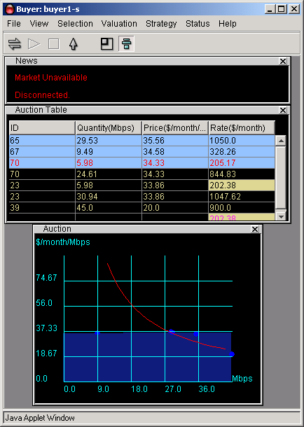

Auction Table
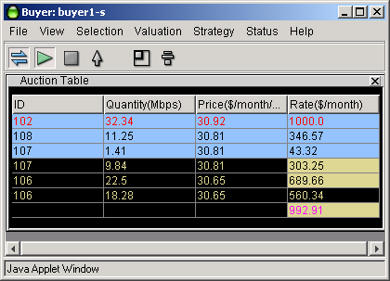
The Auction Table gives you a quantitative, real-time view of the auction in progress.
The columns of the Auction table may be resized (by clicking and dragging column boundaries in the header) or reordered (by clicking and dragging the column headers themselves). The columns are:
- The ID of the bidder. A bidder receives a new ID whenever it is uploaded from the garage.
- The quantity requested in the last bid placed (note that this may be split into multiple rows, as explained below).
- The price (unit price) requested in the last bid placed.
- The "rate" represented by the bid. This is the quantity times the price. It is the maximum cost represented by that bid, but not necessarily the price that will be paid by the bidder.
The elements of the rows of Auction Table are as follows:
- Your agent's last bid is shown with a red font. The last bids of all other agents are shown with a black font (in the blue shaded area) or with a yellow font (in the black area).
- Any bidders, including your agent, which receive an allocation of bandwidth are shown in the blue shaded area. Any bidder who does not receive an allocation is shown in the black area. If a bidder receives only a portion of an allocation, they are shown in both the blue and black areas, with their quantity split accordingly.
- The black area is used to represent the basis for the actual cost paid by your agent if it has received an allocation of bandwidth. How this is actually done is a fairly advanced topic. In summary, the yellow shaded areas to the right of the uppermost bidders in the black area indicate the basis of your cost, and the yellow shaded number with magenta font at the bottom of the table indicates your total cost. To figure your corresponding unit price, divide this number by the amount of bandwidth indicated for your agent in the blue shaded area.

Uploading and Exiting
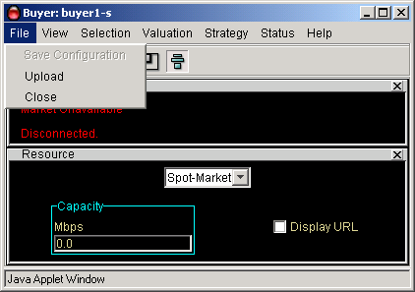
When you wish to terminate a session on your desktop, you will generally want to upload your agent to the garage to continue bidding on your behalf. (Currently, uploading your agent is the only way to save configuration changes. In a future release, you will be able to save configuration changes to your agent's profile in the garage without exiting your desktop agent.)
Use either the up-arrow in the icon bar, or the "Upload" menu-bar item in the "File" category to access this function. You will be presented with a confirmation query message, as shown, below.
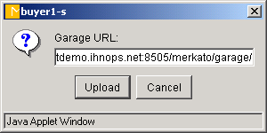
The confirmation message indicates the URL of the garage where your agent will be placed. If you press "Cancel" at this point, you will be returned to the desktop agent and no upload will occur. If you upload an active agent, you will be shown an informational dialog box, as shown, below.
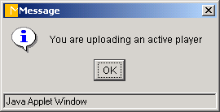
In rare instances, you will want to close your desktop window without updating your agent's profile in the garage. You will do this by selecting "Close" rather than "Upload" in the menu-bar list. When you do this, the following confirmation screen will be displayed:
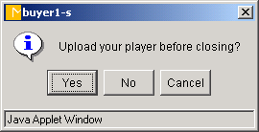
Selecting "Yes" will result in an "Upload" being done before the "Close".
Selecting "No" will result in your desktop agent window being closed without saving any changes you might have made.
Selecting "Cancel" will return you to your desktop agent. Neither an "Upload" or "Close" will occur.

Help
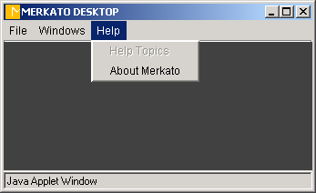
Help screens are available at both the desktop and the agent level.

Reservation Market Agent Window
The Reservation agent gives the user the ability to obtain bandwidth for an extended period of time at a fixed price. The pricing is set by the seller and depends both on the quantity of bandwidth desired and the duration of the reservation. In the current version of Merkato, all reservations begin immediately and there is no reservation fee.
Reservations may be cancelled at any time prior to expiration, but there is a cancellation fee based on a percentage of the remaining value of the reservation. The seller sets this percentage, which may be any value between 0% (no penalty for cancellation) to 100% (no refund on cancellation). The cancellation percentage is quoted to the user at the time the reservation is made and again when the cancellation is confirmed.
Reservations are created using the Reservation Strategy panel. Active reservations are viewed and cancelled via the Reservation Table panel. These panels are not accessible unless the resource selected in the Resource panel supports reservations.
Reservation agents must be uploaded into the garage when you no longer want them displayed on your desktop. The risk for not doing so is not as significant as for the Spot agents. You will simply lose the current entries you have made in the reservation request fields, but not the reservations themselves if you have confirmed them.
The following sections describe the use of these reservation panels in detail.

Resource Panel
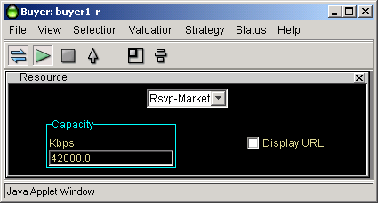
Although a reservation and spot marketplace may allocate the same physical resource, they are controlled by Merkato via separate Resource Agents. In this version of Merkato, bandwidth is pre-assigned to each one of these markets, so reservations do not take bandwidth from the spot market or vice versa.
In order to access the reservation panels, you must select a reservation resource from the Resource panel. The “Capacity” display in the Resource panel informs you as to the bandwidth currently available to you in that marketplace, taking into account quantities currently being allocated to other reservation buyers.

Reservation Strategy
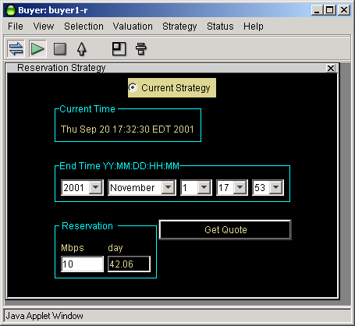
The Reservation Strategy panel is used to create a reservation. Since reservations start immediately, there are no “Start Date/Time” entry fields. The current time is displayed instead. (Note that there may be a delay of as much as 5 minutes from the time the user confirms a reservation until it becomes active).
The middle group of pull-down fields represents the end date and time. It is up to the user to make sure that the date is valid (No February 30th, for example). Should you inadvertently enter an invalid date, this will be revealed to you in the confirmation pop-up window and you can reject the reservation and make the appropriate changes.
The third group of information entry display fields, at the bottom of the panel, indicate the desired quantity and calculated duration, respectively. The units for these fields match those selected in the Units panel. To complete your desired reservation profile, enter your desired amount of bandwidth and press “Get Quote”. A pop-up confirmation window will appear, similar to that shown below.

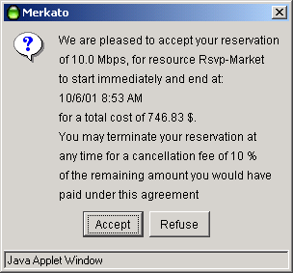
This confirmation form informs you of:
- The amount you have requested
- The end date and time of your reservation
- The total cost (unit cost times quantity time duration) of your reservation
- The percentage cancellation fee, applied against the remaining value of the reservation, which will be charged should you elect to terminate a reservation before the end date and time.
Look over all this information carefully before you press “Accept”. If the end date and time is different than you specified, it indicates that you entered an invalid date and Merkato made the best guess of your intent by adding the duration to the current date and time.
Note that given the free-form nature of these fields, it is possible to specify a date and time before the current time. This will be represented by a negative duration in the strategy panel. Should you ignore this (or specify a reservation of less than 5 minutes) you will receive the following error message in place of the reservation confirmation pop-up window.
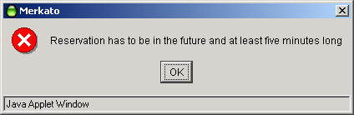
If you specify a quantity which cannot be allocated to you due to other active reservations, you will receive the following error message in place of the reservation confirmation pop-up window.
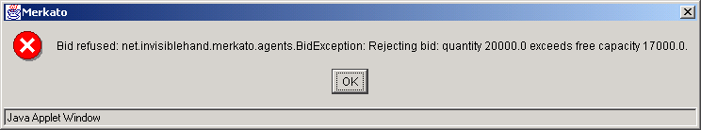
This error message informs you of both your requested quantity and the quantity available, so you an make appropriate adjustments

Reservations Table
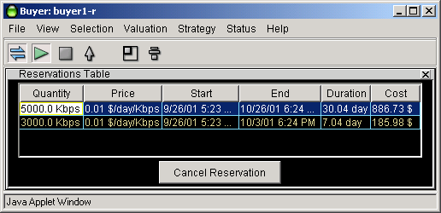
The reservations table allows you to view and cancel reservations.
When you have confirmed your reservation, it will appear in your Reservation Table. The reservation table is accessed through the “Status” menu-bar list.
The columns of the reservation table may be resized and reordered. To resize a column, click and drag the boundary line between columns within the column header. To move a column to another position, drag and drop its header either to the right or to the left of its current position.
Should you desire to cancel a reservation, click anywhere in the row that represents the reservation. The reservation will be highlighted in blue. Then press the “Cancel Reservation” button at the bottom of the panel.
You will be presented with a confirmation pop-up window similar to that shown below.
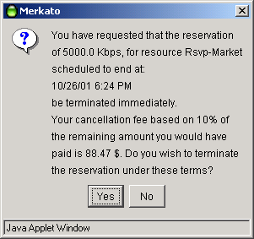
The reservation cancellation confirmation screen indicates the following information:
- The quantity of the reservation
- The scheduled end date and time of the reservation
- The percentage cancellation fee which will be applied to the remaining value of your contract if you confirm the cancellation
- The total amount that you will be billed, based on the remaining duration of your reservation, the original total value of your reservation, and the percentage cancellation fee.
If you wish to proceed with canceling the reservation under these terms, press “Yes”. If you wish to not cancel your reservation, press “No”.

