

Merkato Version Portal-Express 2.0.1 Help
What is Merkato? 3
Getting Started 18
Agent Login 20
Installing the Java Plug-in 27
Configuration Wizard 33
Desktop Interface 52
Spot Market vs. Reservation Market Agents 54
Express (HTML) Interface 57

What is Merkato?
Merkato is a unique way to obtain bandwidth, on demand, at fair and equitable prices. Merkato uses a patent pending Progressive Second Price Auction mechanism to collect bids from multiple buyers, analyze the bids to determine the natural market price for this bandwidth, and then automatically apportion that bandwidth to the successful bidders at the market price. (Traffic form unsuccessful and non-bidders are assigned to a small, shared block of bandwidth, called the “best-effort queue”.) The components of the Merkato system are illustrated, below.
Buyers of bandwidth pre-configure theirs agents to be aware of the price they are willing to pay for a range of available quantity. The seller of bandwidth also configures his strategy, which includes the minimum unit price at which he is willing to sell the bandwidth. Buyer and seller agents then express their willingness to pay for bandwidth in the form of bids (consisting of a unit price and quantity) and send them to the central Resource Agent. (Sellers create a price floor by ofering to buy their own bandwidth at their lowest acceptable price.) The resource agent responds to bids with proposed allocations and pricing, which the buyer and seller agents can either accept (by not bidding further), or reject (by submitting another bid). When there is no more bidding, the auction closes, and actual allocations are made. The entire process takes no more than 5 minutes, and often considerably less time. The auction is completely open and fair, with all bidders seeing what the other bidders have offered (but anonymously). The Progressive Second Price auction mechanism ensures that all bidders receive their allocation at the fair market price, which will be equal to or less than the price they offered.

The core of the Merkato system is the Resource Agent. The Resource Agent is responsible for
- Collecting bids from active bidders,
- Determining a proposed allocation of bandwidth for each bidder based on the progressive second price auction rules,
- Calculating the market price for each bidder, and
- Distributing all this information anonymously to all bidders.
This represents only a single cycle in the bidding process. Bidders who did not receive an allocation or whose allocation was less than requested, may submit another bid in order to improve their position. This cycle continues until each bidder is satisfied with their allocation, or cannot bid at the current market price. When bidding is complete, the Resource Agent will
- Inform all bidders of the final results,
- Send the bandwidth distribution information to the network driver for implementation the bandwidth distribution, and
- Send the billing information to the accounting database.
Although the auction allocation process is run continuously, there is no need for users to be directly involved at all times. Your agent will bid automatically based on a strategy, which you prepare in advance.
Your financial limits, bandwidth desires, and bidding strategy are expressed using templates provided via the Merkato user interface. These templates are created using the Valuation and Strategy panels in the interface
Once the bidding plan is in place, Merkato offers the user the option of configuring their agent and bidding from their desktop, or remotely communicating with their agent, which bids from a server co-located with the Resource Agent (this eliminates the potential of ceasing to bid due to desktop PC problems or network connectivity problems). The location near the Resource Agent from which the agent bids is referred to as the “Garage”.

Getting Started

Agent Login
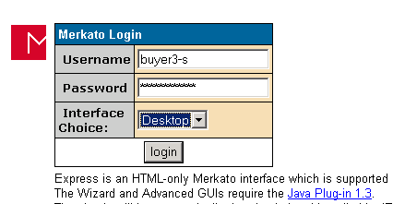
Your entry point to access the Merkato agent is the Merkato login screen. Enter your username and password, then select your interface choice:
- The “Wizard” interface walks you through the steps to set up your Merkato agent to obtain bandwidth on your behalf. The settings are automatically transferred to your agent and can be viewed and altered from either the Desktop or Express interfaces.
- The “Desktop” interface allows you to purchase bandwidth through a series of user-selectable panels. Your “agent” is brought to your desktop and bids on your behalf from there.
- The “Express” interface communicates with your agent in the “garage” to change configuration information and obtain status.
It is recommended that you select the Wizard interface first to make basic buying choices. As you become more advanced in your use of Merkato, you will want to make further changes through the Desktop interface. The Desktop interface also gives you the most detailed status information. As you become more proficient with Merkato, you may want to use the Express interface to make quick configuration changes and status checks without downloading your agent to your desktop.

Installing the Java Plug-in
If this is the first time you are using Merkato on your desktop, you must download the Java version 1.3 (or higher) plug-in to your browser before accessing the Desktop or Wizard interfaces. You can allow Merkato to do this automatically for you, or you may download it directly from the source whose link is provided in the login page.
If neither of these methods is available to you, you may download it free from Sun Microsystems. The URL is:
http://java.sun.com/products/plugin/
Follow the instruction and download the plug-in for either Microsoft Explorer or Netscape Navigator, depending on the browser application you use. (Note: As of this writing, to get the plug-in, you must download the entire Java Run Time Environment, which is greater than 5 MB in size).

Configuration Wizard
The “Wizard” interface walks you through the steps to set up Merkato to obtain bandwidth on your behalf. The Wizard may be used alone (when launched from the original login screen), to alter settings to your agent in the “garage”. It may also be used to alter settings in your agent on your desktop when launched from a pull-down menu-bar in the Desktop interface.
When “Wizard” is first launched, the following panel appears:
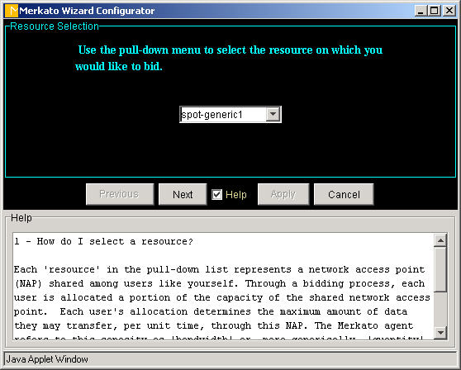
You will be guided step-by-step in the process of making the following configuration decisions:
- The resource from which you wish to purchase bandwidth
- The currency, quantity, and time units with which you would like to express your purchasing requirements. (Changes can be made at any time and your previously entered values will be scaled to match your new units)
- Your minimum bandwidth requirements
- Your maximum bandwidth requirements
- Your budget for purchasing bandwidth
- What state you wish your agent to be left in following the configuration changes (bidding or non-bidding)
Each panel is accompanied by a “help” subpanel which can be activated using the check box at the bottom of the screen. The “help” panel provides information about the impact of the parameter you are setting and provides advice on making a choice.
The values configured in your agent at the time the Wizard is activated are displayed as initial values in the applicable fields.
You may use “Cancel” at any time to exit the Wizard without making changes. You will be asked to confirm your desire to exit the Wizard with a dialog box such as the one below.
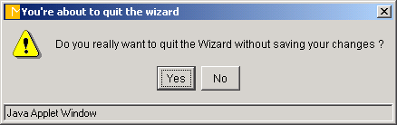
Use the “Next” and “Previous” buttons to navigate forward and backward through the Wizard. Until you press “Apply” at the last screen, none of your changes take effect. When you press “Apply”, you will see the following confirmation screen, at which time you can confirm your desire to apply your changes, or return to the Wizard.
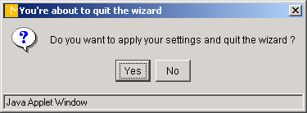

Desktop Interface
The “Desktop” interface allows you to purchase bandwidth through a series of user-selectable panels. Your “agent” is brought to your desktop and bids on your behalf from there.

Spot Market vs. Reservation Market Agents
There are two ways to purchase bandwidth in a Merkato system. You may request and receive a fixed amount of bandwidth, at a fixed price, for a fixed term, or you may create a bidding strategy and contend for bandwidth with other buyers at frequent intervals. The first method is called the Reservation market and uses a reservation agent. The second method is called the Spot market and uses a spot agent. Depending on how your administrator has set up your Merkato system, you may have separate usernames for each type of agent or they may share a common username and password.

Express (HTML) Interface
The Express interface is an HTML version of the Desktop interface, with some significant differences:
- It leaves your agent in the garage and queries and controls it remotely. Should you inadvertently close this window, it will make no different to your agent in the garage.
- Your screen is not updated in real time. You must press the “Refresh” button to update informaiton in status displays.
The Express interface is meant to support advanced users who know what the fields mean and wish to have a quick way to check agent status or make configuration changes.
You access the Express interface through the original log-in browser window, shown below.
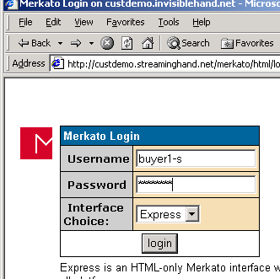
If your agent was active and bidding from the garage, you will see a window like the one below.

The three buttons at the bottom of the window control your communication with the Resource Agent.
- “Refresh” updates the read-only status fields in the windows without sending configuration changes to the Resource Agent
- “Apply” updates the read-only status fields in the windows and sends configuration changes to the Resource Agent.
- “Submit” sends configuration changes to the Resource agent and exits.
To exit the Express window without sending configuration changes to the Resource Agent, simply close the browser window.
The fields in this display are as follows (identified by their row headers):
- “Status” – Controls whether the agent is bidding or not. You must press “Apply” for this change to take effect.
- “Resource” – Selection list for the resource for which you are bidding. You must press “Apply” for this selection to take effect.
- “Strategy” – Auto Strategy is the only strategy supported by the Express interface. Manual strategy can be selected, but there is no bid entry fields. Reservations panels are not currently supported.
- “Valuation View” – This is a pull-down menu to select the valuation displayed in the fields immediately below this panel. The displayed valuation only becomes the current valuation when “Apply” is pressed.
- “Current Valuation”. The current active valuation is indicated by the “Current Valuation” display.
- Valuation Fields - The next panel or panels contain the settings for the valuation chosen. You must press “Apply” after changes are made, for them to take effect.
- “Bid” – A read-only display indicating the latest bid submitted. You must press “Refresh” to update this display. If this display is missing, it indicates that your agent is inactive and not bidding.
- “Allocation” – A read-only display indicating the allocation received in the last round. You must press “Refresh” to update this display. If this display is missing, either your agent is “inactive”, or you did not receive an allocation in the previous round.
- “Units” – Changes the units for all other displays. All values are scaled to reflect the change in units. You need not press “Apply” for this change to take effect.
When your agent is inactive and not bidding from the garage, the Bid and Allocation rows will be missing, as shown below.
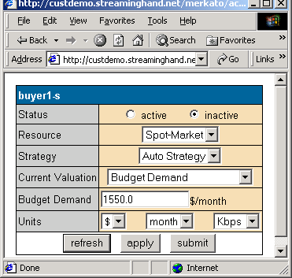
Error messages are displayed above the Express agent panel, in the same browser window, as shown below.
